***Mahatma Gandhi Shikshan Mandal’s***

**Smt. Sharchchandrika Suresh Patil**

**Institute of Technology (Polytechnic), Chopda**

****

**A Project Report On**

**“[Online quiz web app](https://www.bing.com/ck/a?!&&p=d03f3ffbef3c30fbJmltdHM9MTY3NzYyODgwMCZpZ3VpZD0zNDBmMmQ0Yy01ZWY1LTZiODUtMDQ3NS0yMmE3NWY2ZTZhYzUmaW5zaWQ9NTUyOA&ptn=3&hsh=3&fclid=340f2d4c-5ef5-6b85-0475-22a75f6e6ac5&u=a1L3NlYXJjaD9xPU9ubGluZStxdWl6K3dlYithcHAmRk9STT1BV1JF&ntb=1" \t "_blank)”**

**Submitted By: -**

**1.Kumbhar Mayur.**

**Guided By: -**

**Prof. D. M Fegade**

**Department of Computer Engineering 2020-2021**

|  |
| --- |
| **Index** |

|  |  |  |
| --- | --- | --- |
| Chapter No | Title | Page No |
| 1. | **Introduction** | **3** |
| 2. | **Existing System**   * **Description** * **Proposed System** | **4** |
| 3. | **System Requirements**   * **Software Requirements** * **Language Requirements** * **Database Related Requirements** * **Hardware Requirements** | **6** |
| 4. | **Functional Specification**   * **Login Module** * **Menu Module** * **Order Module** * **Booking Module** | **8** |
| 5. | **System Design**   * **Data Flow Diagram** | **10** |
| 6. | Conclusion   * Advantages * Limitation * Future work | **13** |
|  |  |  |
|  |  |  |
|  |  |  |

**Chapter 1**

**Introduction**

Online quiz web app is a technology-driven way to simplify examination activities like defining exam patterns with question banks, defining exam timer, objective/ subjective question sections, conducting exams using the computer or mobile devices in a paperless manner in Webpage

It is also needed less manpower to execute the examination. Almost all organizations now-a-days, are conducting their objective exams by Online quiz web app, it saves students time in examinations..

While clicking the ‘Start Examination’ button the student has an nofication to exam And then student clicking on the continue button and user have going to the Examinition page.

The student has on exam page and they are showing the MULTIPAL CHOICE QUESTIONS (MCQ) and student are clicking on correct option then the page are showing the Correct oprion, and the student are giving the 15 seconds per question.

Then student clicking on Submit button then showing the result…How many questions are wrong , and How many questions are currect.

**Chapter 2**

**Existing System**

* **Description –**

It provides comprehensive examination experience for both students and teachers alike. It is less laborious and overhead intensive examination experience since it automated and digitized the examination administration experience, while also ensuring greater flexibility and access for students from all corners of the world.

Simply put, with innovations in technology, an increasingly globalized world, and data-driven insights into teaching and learning methodologies, an Online quiz web app might provide a better perspective into the scholarly journey of a student. Examinations are not just a part and parcel of student life. They are an evaluative tool that allows students, teachers, and parents to track and measure the student’s scholarly progress. It also serves as a concrete metric on which to base learning and teaching decisions for the future.

An Online quiz web app can have a variety of features that would be helpful to both teachers and students alike. Below we discuss some key features in detail along with the benefits they bring to the table over a traditional pen and paper examination:

The online examination software allows users to create examination papers by subject and using multiple-choice questions. This kind of granular ability to create curated questions ensures that examinations remain dynamic and up to date instead of being outdated or outmoded in any way. It also means that a constant stream of questions is being added to the institutional knowledge of the collage in question or even archives of a question bank for future educators to use.

* **Proposed System –**

As we mentioned above the limitations of questions management. Here we are going to see about our “Online quiz web app” software. Its advantages, why to use it etc. Using a software to manage all the task of exam is easy and efficient. we can develop it as per our comfort and requirements.

Using this software or webpage, we can allow user to see get the exam and brows our software according to their choice. They can select their choice of MCQ optiond their no one to look back to them, inconvenient. They can also

In online created for taking test has following features.

* In comparision to the present system the proposed system will be less time consuming and is more efficine.
* Result will be very precise aand accurate and will be declared in very short span of time because calculation and evaluvation are done by the simulator itself.
* **Steps to appear for an Online Exam**

1. Go to Candidate Login page.
2. Enter Candidate username and password.
3. Click on Login.
4. After login candidate, there will be a display of **exam** details.
5. Click on start exam to appear for **exam**.

**Chapter 3**

**Resources**

* **Software Resources**

1. Sublime Text3 – **Sublime Text 3**  is a lightweight, cross-platform code editor known for its speed, ease of **use**, and strong community support. It's an incredible editor right out of the box, but the real power comes from the ability to enhance its functionality using Package Control and creating custom settings. It provides basic features so that we can type the easily: -

* Goto Anything. Use Goto Anything to open files with only a few keystrokes, and instantly jump to symbols, lines or words. ...
* Goto Definition. ...
* Multiple Selections. ...
* Command Palette. ...
* Powerful API and Package Ecosystem. ...
* Customize Anything. ...
* Split Editing. ...
* Instant Project Switch.

1. Operating System – **Sublime Text** runs on the Windows, Mac and Linux **operating systems**. It supports x86 (32bit) and x86\_64 (64bit) processors. ARM processors are not supported..

* **Language Resources**

**Sublime** dpaste – Sends selected **text** to the dpaste.com **service**. SublimeLinter – Code linting (validation) for JavaScript, Perl, PHP, Python, Ruby, CSS,HTML and others.

* **Database Resources**
* As I mentioned above, the currently supported **database** types are MySQL, PostgreSQL, SQLite and MariaDB, and once you connect to a **database** successfully, the connection will be stored for future **use** (every time you connect to a **database**, you'll be shown a list of these stored connections you can choose from).
* **Hardware Resources**

1. **Processor –** Core i3 or core i5 having at least 4GB RAM.
2. **Disk Space –** 100 MB or more

**Chapter 4**

**Functional Specification**

The online examination system has many modules to make the software more efficient and user friendly. The modules make the database management easier. The modules are made according to their working or requirements.

* **Login Module –**

Login module consist of authenticating user as the user is valid or not.

The use is assigned with a particular username and password so that the user has its security in its own hands. The login module allows the authenticated user to enter into the software.

* **Start Exam Module-**

Start Exam module consist of button to go the next steps means the examination details .

* **Rules page Module-**

In Online quiz web app when we clicked on Start examination Button then open the Some Rules Of This Examination and show details of this examination.In this page shows options for studets to Buttons

* Logout
* Exit exam
* Continue.

* **Main MCQ Module –**

In a online exam studente shws the most beutifull and attractive page to students. And In page show following activities..

* Time-left
* Progressbar in MCQ que.
* Provide Questions
* Provide Options for Ans.
* Provide stutas max & min Questions
* Next Button…

**Chapter 5**

**System Design**

* **Data Flow Diagram –**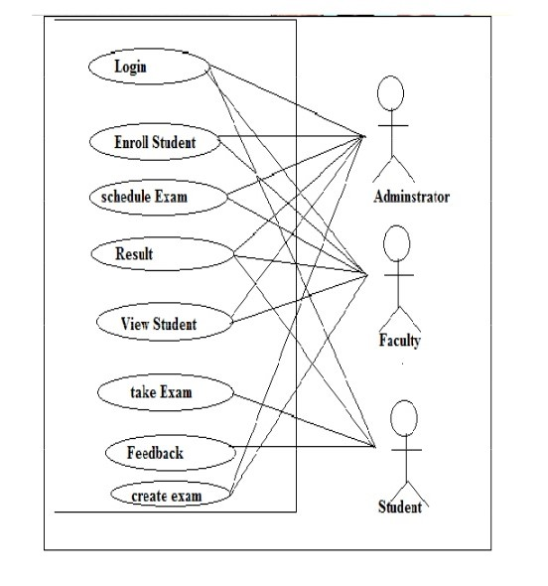

**DFD level 1 – Start exam Model**

**start** **Module**

**Select option**

**15 seconds**

**When 15 complete**

**Click on next butt.**

**MCQ question page**

**When ans is selected**

**Progressbar**

**Time Left 15 seco.per que**

**Chapter 7**

**Implementation**

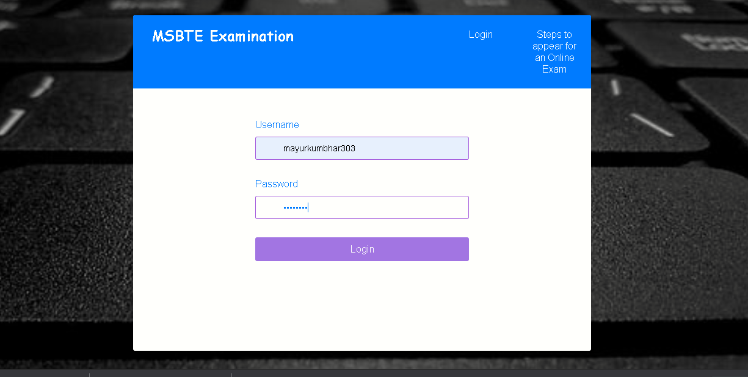

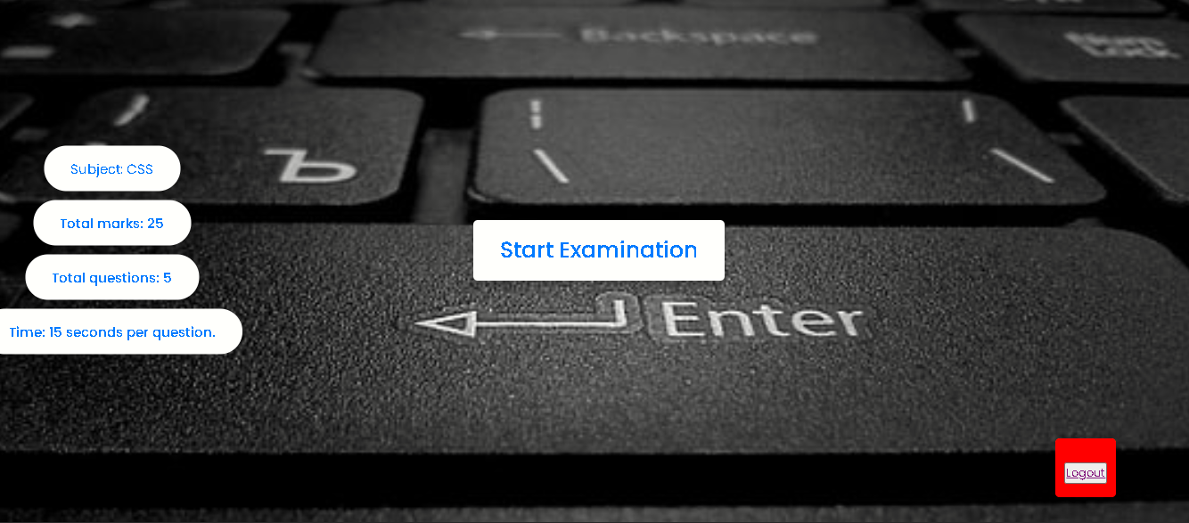

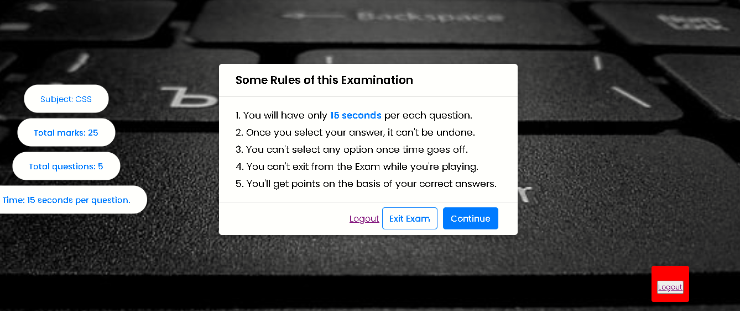

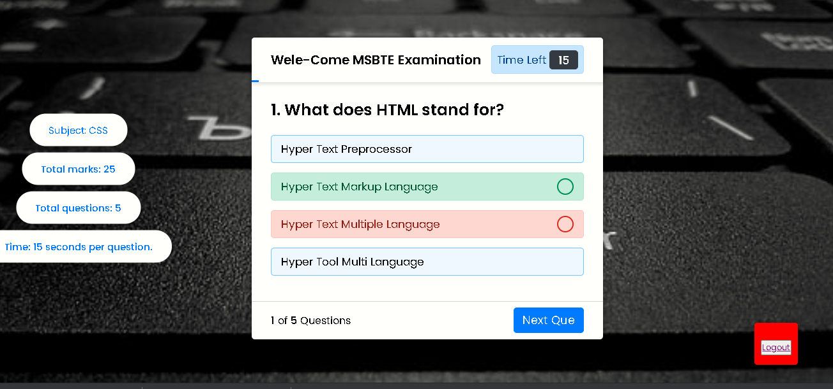

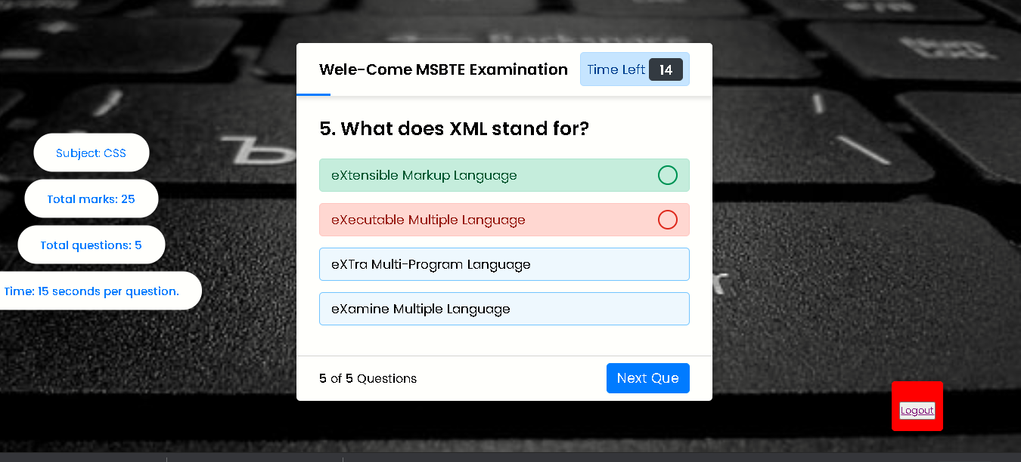

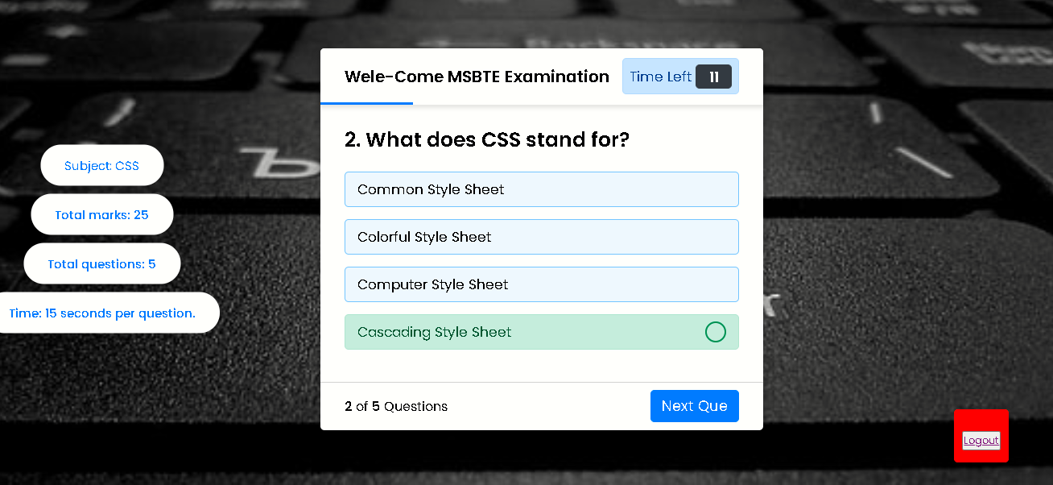

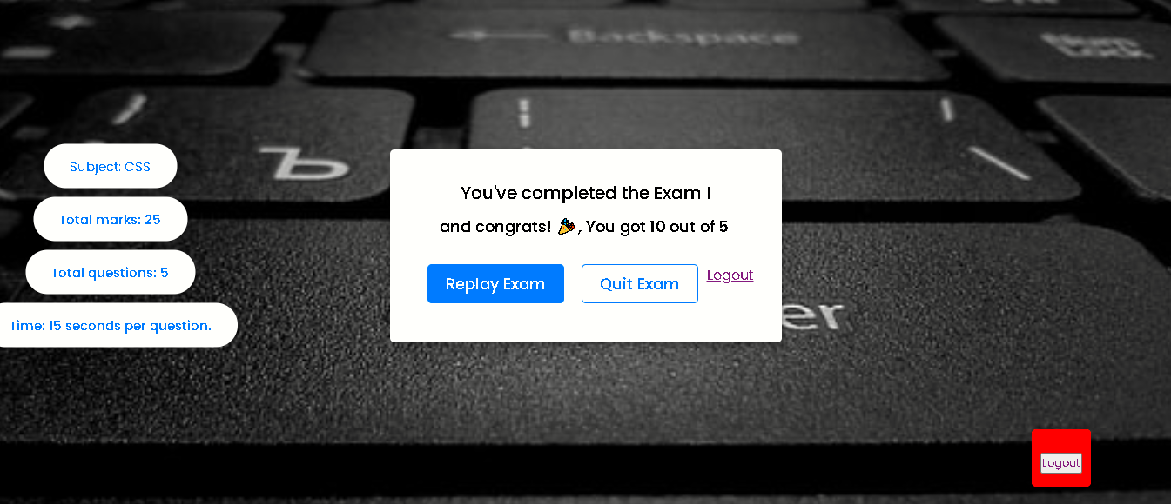

**Chapter 8**

**Conclusion**

* **Advantages –**
* A better option for distance learning.
* Hassle-free assessments.
* Arouses student interest.
* **Security**.
* Environment-friendly and **cost**-effective solution.
* Instant evaluation for faster results.
* Exhaustive reports to identify gaps and work for the improvement.
* **Limitations –**
* A better option for distance learning.
* Hassle-free assessments.
* Arouses student interest.
* **Security**.
* Environment-friendly and **cost**-effective solution.
* Instant evaluation for faster results.
* Exhaustive reports to identify gaps and work for the improvement.
* **Future Work –**

1. Constant technological development leads to a rapid expansion of the assessment industry. ... It clearly proves that the **online examination** software is the **future** of assessment methodology. Coaching institutes and learning centers are adopting new techniques and eliminating traditional assessment techniques.